NEWS
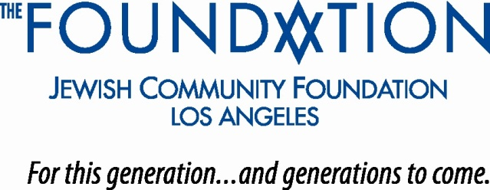

PHOTO AND CUTLINE

FOR IMMEDIATE RELEASE

Contact:
Lew Groner Jerry Freisleben
Jewish Community Foundation FoleyFreisleben LLC
(323) 761-8722 (818) 788-0010

JEWISH COMMUNITY FOUNDATION OF LOS ANGELES’S DAN ROTHBLATT
RECOGNIZED WITH NATIONAL PHILANTHROPY DAY SHINING STAR AWARD
-------------------------
Recognition by Association of Fundraising Professionals L.A. Chapter Marks
30-Plus Years of Contributions to Nonprofit Profession Locally
_____________________________________________________

HIS STAR SHINES BRIGHTLY—Jewish Community Foundation of Los Angeles (The Foundation) Executive Vice President Dan Rothblatt (pictured) was the recipient of the 2020 Shining Star Award bestowed by the Association of Fundraising Professionals Greater Los Angeles Chapter in conjunction with the 35th anniversary of National Philanthropy Day.
Rothblatt received the recognition as part of the organization’s 2020 Virtual Conference and Awards Program held Nov. 13. The award was presented by longtime friends and former colleagues Rabbi Gary and Tamara Greenebaum, who paid tribute to Rothblatt’s 30-plus years of work in nonprofit development across the Jewish and general communities in Los Angeles. Over that period, Rothblatt has become widely admired and respected throughout the Jewish communal services and nonprofit profession at large for his tireless contributions as a professional nonprofit leader, speaker, author, consultant, mentor, adjunct university educator and facilitator of an online resource that connects nonprofit jobseekers to career opportunities.
Since joining The Foundation in 2007 as a member of its leadership team, Rothblatt’s portfolio of responsibilities has expanded to include leading
-more-
Rothblatt Named National Philanthropy Day Shining Star/2-2-2
development, as well as oversight of the grantmaking, marketing, and donor- and professional-adviser relations functions. In the past 13 years, the institution’s donor base has mushroomed with the establishment of several hundred new charitable funds as total assets have surpassed the $1 billion threshold and grantmaking has significantly increased. The Foundation has granted more than $1 billion in this period.
Earlier, Rothblatt served as deputy director for development for the Los Angeles Philharmonic Association, where among his charters was opening the iconic Walt Disney Concert Hall. Other experience includes tenures with the Jewish Federation of Greater Los Angeles, American Jewish University, American Jewish Committee and Northridge Hospital Medical Center.
Rothblatt earned master’s degrees in social work and Jewish communal service from, respectively, USC and Hebrew Union College, where he was bestowed an honorary doctorate degree in recognition of his professional achievements. He received two awards from the Jewish Communal Professionals of Southern California. A native of San Francisco, Rothblatt and his wife, Jayne, reside in Valley Village and are the parents of an adult daughter.
About The Jewish Community Foundation
Established in 1954, the Jewish Community Foundation of Los Angeles manages charitable assets of more than $1.3 billion entrusted to it by over 1,300 families and ranks among the 10 largest Los Angeles foundations. It partners with donors to shape meaningful philanthropic strategies, magnify the impact of their giving, and build enduring charitable legacies. In 2019, The Foundation and its donors distributed $129 million in grants to 2,700 nonprofits with programs that span the range of philanthropic giving. Over the past 13 years, it has distributed more than $1 billion to thousands of nonprofits across a diverse spectrum. www.jewishfoundationla.org
# # #

